**Unit Testing for downloadFile program:**

Some checks are applied at the shell script level such as checking to see if either the file or the directory exists and what actions to take and/or messages to show. The Scala program for downloading the file performs the following 4 checks:

1. Checks to see if the directory does not exist
2. If malformed URL is entered, such as, ht://…
3. If the file does not exist in the URL path and results in response code greater than 400
4. If the host is unknown (i.e., no DNS entry to connect to)

Below are the screenshots of testing the above scenarios:

1. **Directory does not exist:**

First create the docker image either without /app/data directory or rename the data directory to something else. Below is the output you will get from the shell script if you run the docker image.

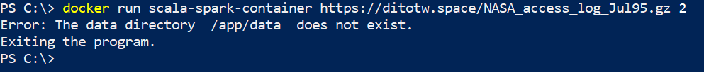

There is another check in the Scala program and for that you need to log into the container in an interactive mode, delete the /app/data directory and then run the Scala program to test it. Below is output shows that example.

1. **Malformed URL:**

Note that the URL path starts with ht://. That will cause the below error.

1. **File does not exist on the remote host - HTTP Response:**

Note that the file name does not have proper extension resulting in the below error.

1. **Host name unknown:**

If the host does not exist on the DNS server, then the below error shows up. Note that the hostname below is ditotw.spa

The shell script checks for the arguments passed and covers the following two scenarios:

1. **Less than 2 arguments passed:**

1. **Non-numeric values for N:**

Note that ‘A’ was passed as the second argument instead of a number.

